Gianluca Said AIG-4.1A

Question 1
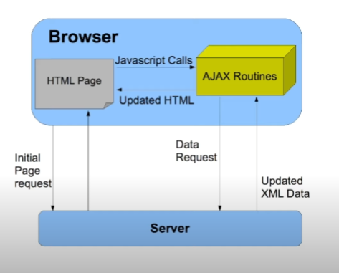
AJAX is a special technique used in web development to make websites more interactive and responsive. Imagine you're using a website, and you want to perform an action like submitting a form or clicking a button. Normally, when you do that, the whole web page would reload, and you'd have to wait for it to load again. It can be frustrating and time-consuming.

But with AJAX, things work differently. When you perform an action on a web page, like clicking a button, AJAX allows the website to communicate with the server behind the scenes without reloading the whole page. It's like having a hidden assistant working in the background, fetching or sending data to the server without you even noticing.
Implementation
Step 1. Figure out when you want the AJAX function to happen. It could be when someone clicks a button, submits a form, or performs any other action on the web page.

Step 2.Start by setting things up. You need to create a special object in JavaScript called XMLHttpRequest (or use a more modern approach). This object acts as a messenger between your web browser and the server.

Step 3.Configure the messenger. You have to tell the XMLHttpRequest object what to do. Specify things like which method to use (like asking for information or sending data), the web address where the request should go, and any additional information you want to send along, like form inputs.

Step 4.Send the message. Once everything is set up, you can send the request to the server. It's like pressing the send button on an email. The special thing is that this happens in the background, so you can continue using the web page without waiting for the server to respond.

Step 5.The server receives your request and does its thing. It performs any necessary tasks, like fetching data from a database or running server-side code to process the request.

Step 6.The server sends a response back to your request. It could be in different formats, like a list of search results or a simple message.

Step 7.Now, it's time to update your web page. Using JavaScript, you can take the response you received and change parts of the web page to show the new information. It's like refreshing only the necessary parts, without reloading the entire page. For example, if you searched for something, the search results can appear right away without a page reload.

Step 8.If there's anything specific you want to do based on the response, you can add some extra instructions. It could be displaying a success message, showing an error if something went wrong, or running additional JavaScript code to update other elements on the page.

Explain what JSON is and discuss the role it plays in Web Design and Development.
JSON, which stands for JavaScript Object Notation, is a way to organize and exchange data between different systems. It provides a simple and readable format for representing structured data using key-value pairs. Think of it as a language that computers and web applications can understand to communicate with each other.

The Role JSON Plays in Web Design and Development:
JSON plays a crucial role in web design and development in several ways:

Data Exchange: JSON is widely used for exchanging data between a web server and a web application. It acts as a common language for sending and receiving data in a structured format. This makes it easier for different systems and programming languages to understand and work with the data.

APIs (Application Programming Interfaces): Many web services and APIs use JSON to send and receive data. APIs allow developers to integrate external services or retrieve data from other applications. JSON simplifies this process by providing a standardized way to format and transmit the data. It enables developers to fetch data from APIs and work with it in their applications easily.

Storage and Retrieval: JSON is often used as a format for storing and retrieving data in databases or as configuration files. It offers a lightweight and flexible way to represent complex data structures. This makes it efficient for storing data or defining settings in a format that is easy to read and manipulate.

Front-End Development: JSON is commonly used in front-end development to populate dynamic content on web pages. By retrieving JSON data from a server, developers can use JavaScript to extract and display the relevant information. It allows them to create dynamic and interactive user interfaces, show data in tables or charts, and provide personalized experiences based on the received JSON data.

AJAX and Web Services: When using AJAX to fetch data from a server without refreshing the whole web page, JSON is often used as the preferred data format. The server can send the requested data in JSON format, and JavaScript can easily parse and process it. This enables developers to update specific parts of a web page dynamically and provide a more responsive user experience.

JSON plays a crucial role in web design and development by providing a standardized format for data exchange, storage, and representation. It simplifies data exchange between different systems, facilitates integration with APIs, and enables the creation of dynamic and interactive web applications.

Identify advantages of supporting technologies.

Mention and discuss 3 advantages of using Ajax (3 marks)
Ajax offers improved user experience, it allows web pages to update specific parts of their content without the need to relode the entire page. This means faster response times and a more interactive website. Example, you can instantly see search results or submit forms without waiting for the whole page to refresh.

Further more it also makes faster and efficient performance AJAX retrieves and manipulates data asynchronously, meaning it can continue working while fetching data from the server. This reduces network delays and server load, resulting in faster and smoother interactions with the web application. It makes your work more efficient and saves time.

Another advantage is seamless integration with backend systems AJAX enables easy integration with backend systems and APIs. You can fetch data from external sources or send data to the server without interrupting the user experience. This allows for real-time updates and the integration of various services like social media platforms or databases. It expands the capabilities of your web application by leveraging external resources.

Mention and discuss 2 advantages of using JSON
So the first advantage is that Json is Easy Data Sharing, JSON provides a simple and readable format for sharing data between different systems. It's like a common language that makes it easy for computers and people to understand and work with the data. JSON's flexibility allows for representing complex data structures accurately, making it efficient for data exchange.
Another advantage is Smooth Integration JSON seamlessly works with web technologies, especially JavaScript. It can be easily handled and manipulated using JavaScript code, which is commonly used in web development. JSON is also widely supported by web services and APIs, making it effortless to fetch and process data from external sources. This integration enables developers to create dynamic and interactive web applications with ease.

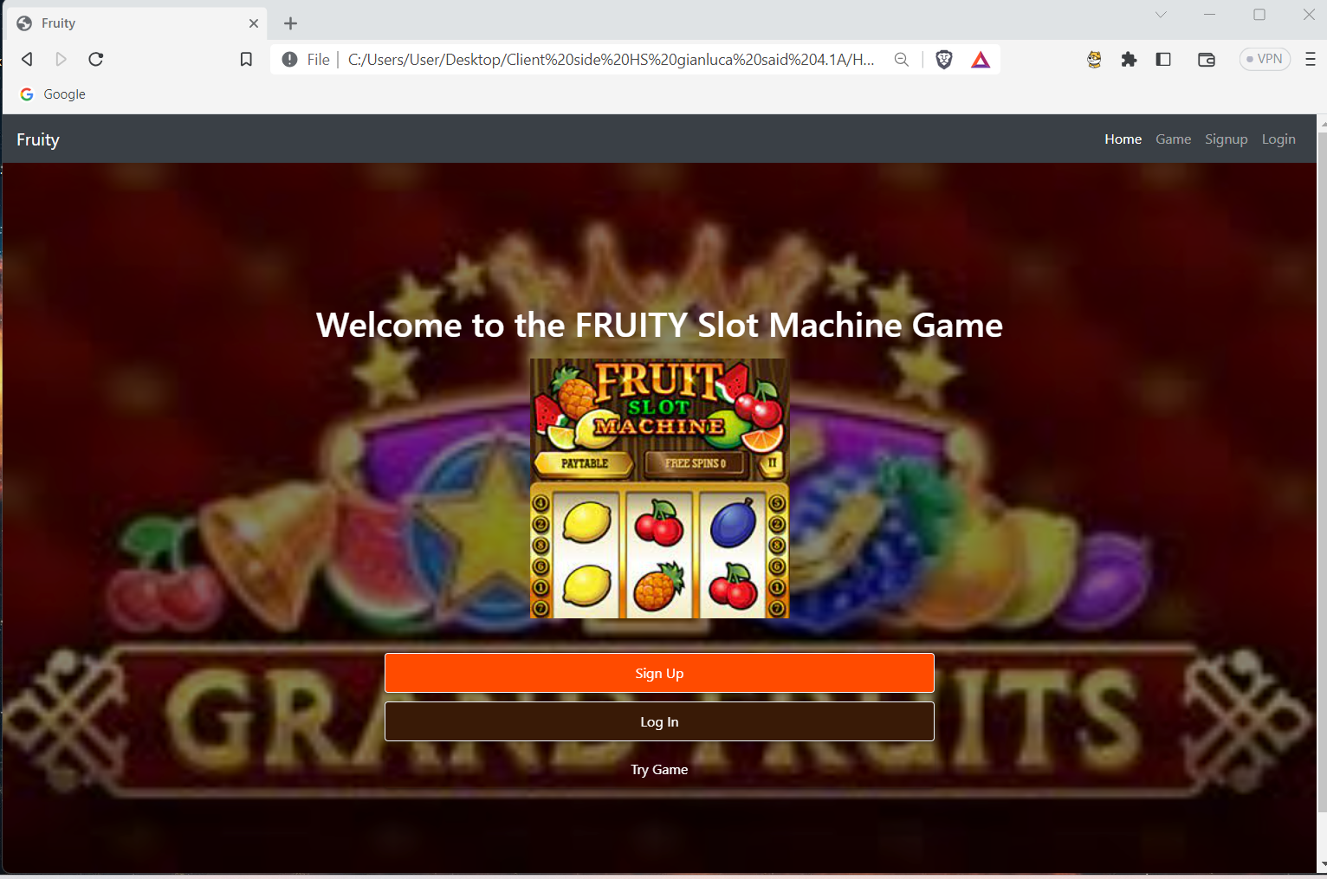
JSON simplifies data sharing by providing a readable format, and it seamlessly integrates with web technologies, making it ideal for building powerful and interactive web applications.
Printscreens for testing burger in different browsers.Brave

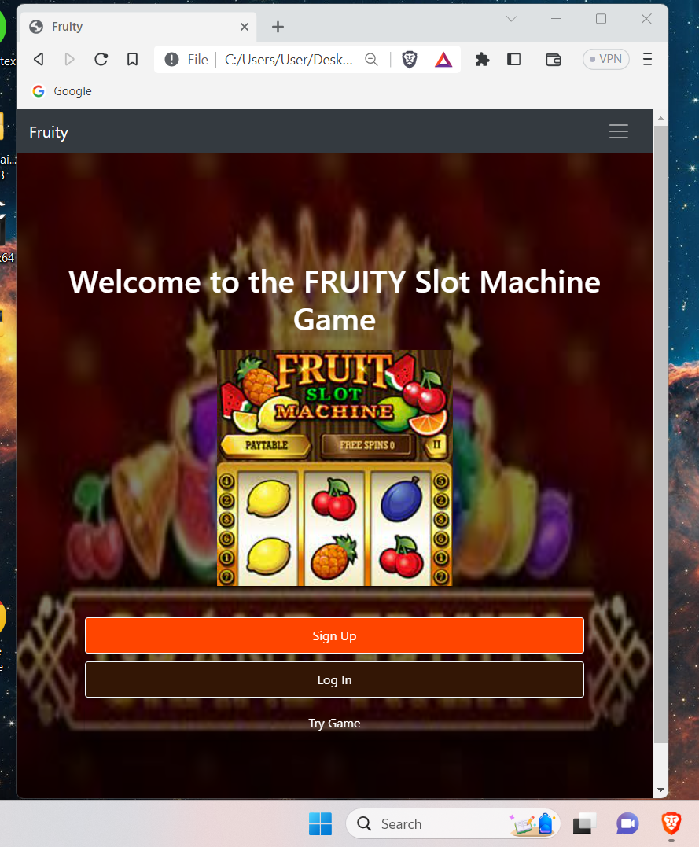

chrome
